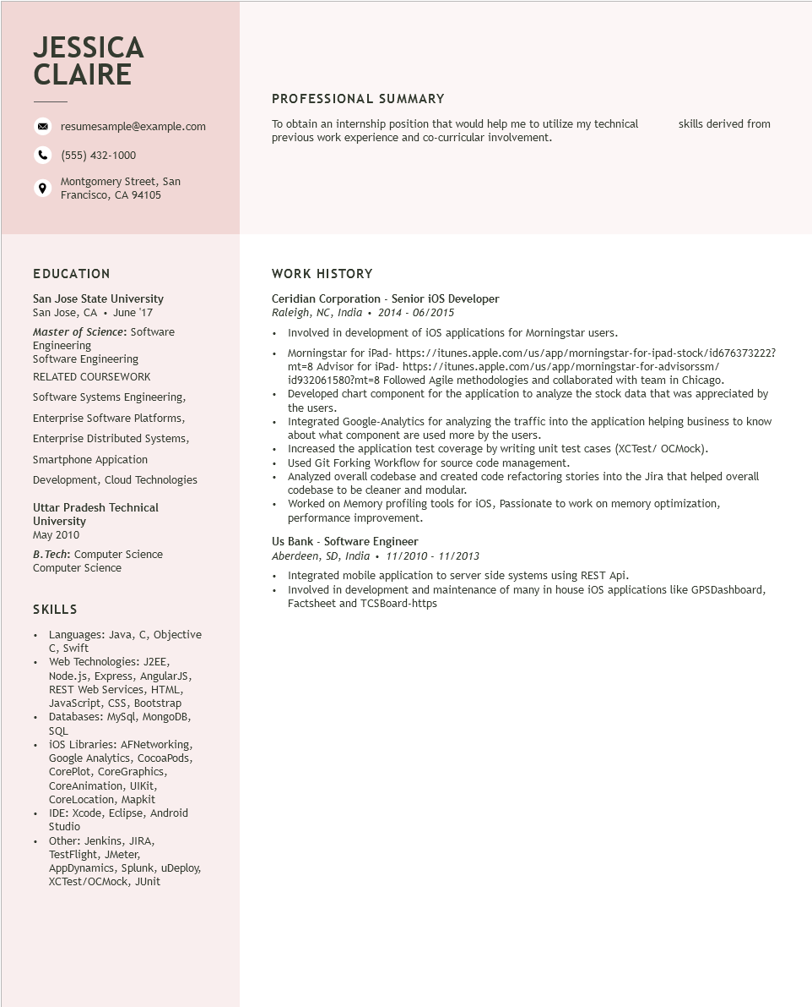
JESSICA CLAIRE
resumesample@example.com
(555) 432-1000
Montgomery Street, San Francisco, CA 94105
PROFESSIONAL SUMMARY
To obtain an internship position that would help me to utilize my technical previous work experience and co-curricular involvement.
skills derived from
EDUCATION
San Jose State University San Jose, CA June '17
Master of Science: Software Engineering
Software Engineering RELATED COURSEWORK Software Systems Engineering,
Enterprise Software Platforms, Enterprise Distributed Systems, Smartphone Appication
Development, Cloud Technologies
Uttar Pradesh Technical University
May 2010
B.Tech: Computer Science
Computer Science
SKILLS
·
•
+
Languages: Java, C, Objective C, Swift
Web Technologies: J2EE,
Node.js, Express, AngularJS, REST Web Services, HTML, JavaScript, CSS, Bootstrap Databases: MySql, MongoDB, SQL
iOS Libraries: AFNetworking, Google Analytics, CocoaPods, CorePlot, CoreGraphics, CoreAnimation, UIKit,
CoreLocation, Mapkit
IDE: Xcode, Eclipse, Android
Studio
• Other: Jenkins, JIRA,
TestFlight, JMeter,
AppDynamics, Splunk, uDeploy, XCTest/OCMock, JUnit
WORK HISTORY
Ceridian Corporation - Senior iOS Developer
Raleigh, NC, India 2014 - 06/2015
⚫ Involved in development of iOS applications for Morningstar users.
• Morningstar for iPad- https://itunes.apple.com/us/app/morningstar-for-ipad-stock/id676373222? mt=8 Advisor for iPad- https://itunes.apple.com/us/app/morningstar-for-advisorssm/ id932061580?mt=8 Followed Agile methodologies and collaborated with team in Chicago.
• Developed chart component for the application to analyze the stock data that was appreciated by the users.
Integrated Google-Analytics for analyzing the traffic into the application helping business to know about what component are used more by the users.
• Increased the application test coverage by writing unit test cases (XCTest/ OCMock).
• Used Git Forking Workflow for source code management.
•
Analyzed overall codebase and created code refactoring stories into the Jira that helped overall codebase to be cleaner and modular.
• Worked on Memory profiling tools for iOS, Passionate to work on memory optimization,
performance improvement.
Us Bank - Software Engineer
Aberdeen, SD, India. 11/2010 - 11/2013
Integrated mobile application to server side systems using REST Api.
• Involved in development and maintenance of many in house iOS applications like GPSDashboard, Factsheet and TCSBoard-https

